EU Declaration of Conformity
Annex IX PPE Regulation (EU) 2016/425
This EU Declaration of conformity refers to the following products
（1） | Product Name | Model | Classification/Type | Batch No./Serial No./Identifier
 | Particle Filtering half mask | HC01 | FFP2 NR
（2）The Manufacturer's name and address is as follows:
Name: | Huizhou Yuanyi Technology Co., Ltd.
Address: | 4th Floor, Building A, No.130, Huize Avenue, Dongjiang High-tech Industrial Park, Zhongkai High-Tech Zone, Huizhou, Guangdong, China
（3）This Declaration of Conformity is issued under the sole responsibility of the Manufacturer.
（4）Detailed description of the PPE to allow traceability/identification of the PPE.
Model: HC01; Classification: FFP2 NR
White folder half mask without valve
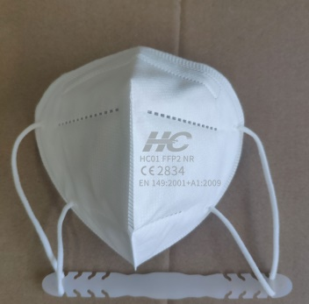 | 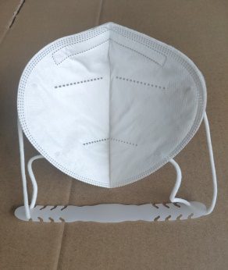
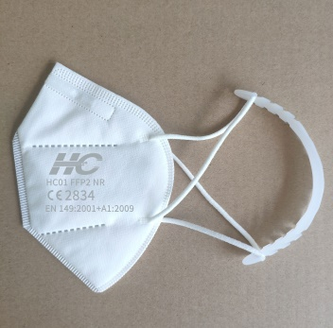 | 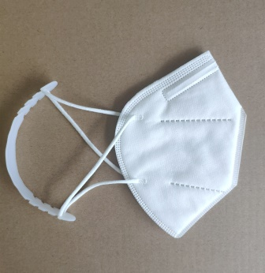
（5）The article identified in (4) above is in conformance with the relevant Union Harmonization Legislation Regulation (EU) 2016/425.
（6）References to the relevant harmonized standards used, including the date of the standard, or references to the other technical specifications, including the date of the specification, in relation to which conformity is declared:
No. | Harmonized standard name
1 | EN 149:2001+A1:2009
（7）CCQS Certification Services Limited. (NB 2834) performed the EU Type Examination (Module B) and issued the Type Examination Certificate Number:
No. | EU Type Examination (Module B) Certificate Number
1
（8）Product Category:
This product is Category II.
This product is Category III and is subject to Module C2 internal production control plus supervised product checks at random intervals and is under the surveillance of CCQS Certification Services Limited. (NB 2834)
This product is Category III and is subject to Module D Conformity to type based on quality assurance of the production process and is under the surveillance of CCQS Certification Services Limited. (NB 2834)
Signature：_______________Date：_____________ Company stamp and/or legal signature： ______________

